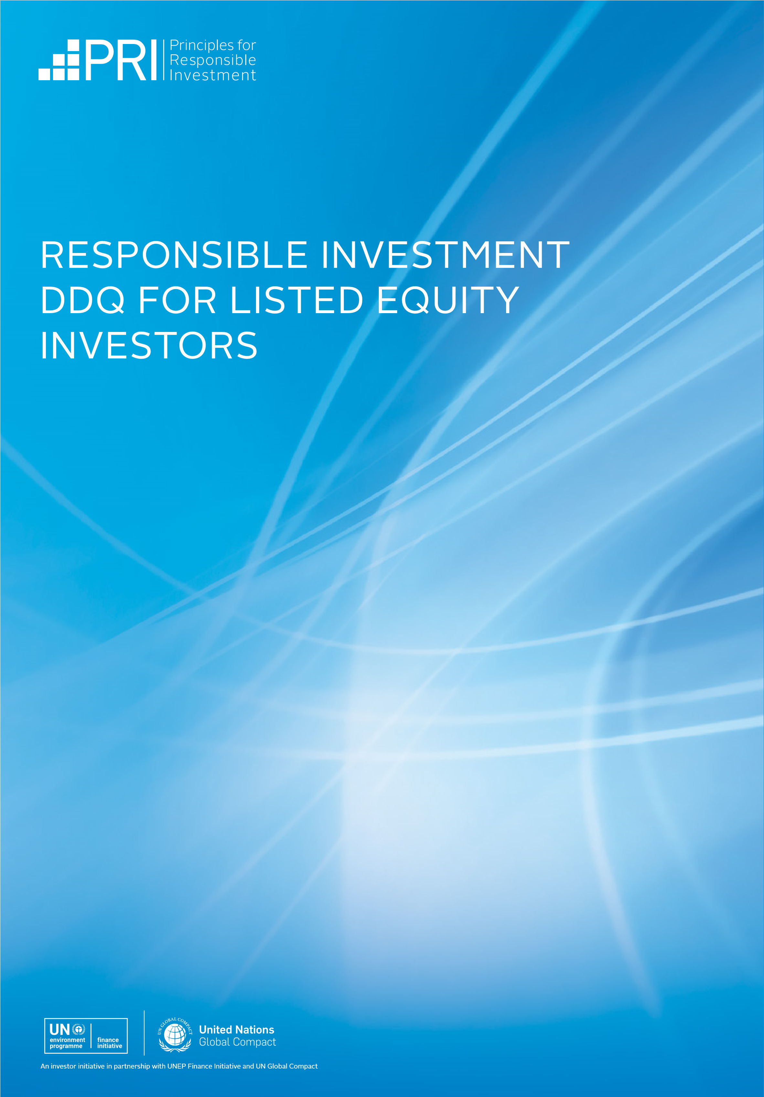

ABOUT THIS DDQ
This due diligence questionnaire (DDQ) has been developed to help investors understand and evaluate listed equity managers’ approaches to responsible investment.

The questions it contains can be used as part of an RFP process, during manager reviews and monitoring, or incorporated into ongoing dialogue. The PRI encourages investors to tailor the questions to suit their broader objectives.

The DDQ should not be considered in isolation, but rather used to support a wider information-gathering process. Investors are encouraged to:
- consider what additional resources are available to enhance their understanding of investment managers’ answers; and
- engage with investment managers to seek additional information and clarification, where necessary.

This DDQ can be used to assess different types of listed equity strategies, including fundamental and quantitative strategies.

To promote consistency, it is designed to complement information gathered through the PRI’s Reporting Framework – particularly the listed equity module – as well as responsible investment disclosure standards and frameworks developed by external organisations. The DDQ will be updated periodically to align with future changes to the PRI Reporting Framework.

NOTES ON USING THIS DDQ
Appendix 1 indicates whether DDQ questions map to an indicator in the Reporting Framework, the requirements contained in the CFA Global ESG Disclosure Standards for Investment Products or the Sustainable Finance Disclosure Regulation (SFDR).

Some questions in the DDQ focus on the investment manager’s overarching approach to responsible investment, while others are specific to a particular investment strategy.

The DDQ provides guidance on the type of information each question is aiming to elicit. Investment managers are encouraged to provide information that goes beyond these points when responding to questions.

Where relevant, we refer to the Reporting Framework glossary of key terms.

Please contact assetowners@unpri.org if you have questions or feedback regarding this DDQ.

DOCUMENT CHECKLIST
A suggested checklist of documents that investors can request from investment managers during the due diligence process.
- Responsible investment policy
- Exclusion policy & exclusion list
- PRI transparency report
- Stewardship policy
- (Proxy) voting policy
- (Proxy) voting records
- Code of conduct
- Sustainability report
- TCFD report

DDQ QUESTIONS

1. POLICY AND GOVERNANCE
  - What is your organisation’s overall approach to responsible investment?
Your overview (no longer than 400 words) should address the following questions: i) Why does your organisation engage in responsible investment? ii) Does your organisation apply responsible investment principles across all asset classes and strategies, or across a selection? iii) Has your organisation’s approach to responsible investment changed significantly in the past 12 months?

1.2 Does your organisation have a responsible investment policy?
If it does, provide a copy. State whether the policy is publicly available, specify the proportion of listed equity assets it applies to and describe the process for reviewing and updating it. If your organisation does not have a policy, explain why not.

1.3 What international standards, industry (association) guidelines, reporting frameworks, or initiatives that promote responsible investment practices has your organisation committed to? Examples include publicly supporting the Paris Agreement, being a PRI signatory, endorsing the TCFD recommendations and participating in the United Nations Global Compact.

1.4 How is responsible investment overseen and implemented within your organisation?
List the roles and/or committees involved in responsible investment activities, including stewardship. Describe how these roles and/or committees are positioned and describe any external resources used to support these activities.
1.5 How are responsible investment objectives incorporated into individual or team performance reviews and compensation mechanisms?
Describe how responsible investment objectives are defined and measured and to which positions they apply (e.g. investment professionals, executive management).

1.6 What responsible investment training does your organisation provide to staff?
Describe what the training covers, which staff receive it, and how frequently it takes place.

2. INVESTMENT PROCESS
2.1 How is ESG materiality analysed for this strategy?
Mention the ESG factors that are analysed (e.g. climate change, human rights) and how their financial materiality is determined, including any tools, standards or data that are used.
2.2 How are financially material ESG factors incorporated into this strategy?
Mention how material ESG factors influence portfolio construction and security selection. For quantitative strategies, mention the use of any back-testing or simulations that are applied to the strategy, and how ESG factors are positioned alongside traditional factors or incorporated into them. Disclose the roles/ committees that are responsible for incorporating ESG factors into this strategy. Provide two examples from the past 12 months of how ESG factors have influenced security selection and/or portfolio construction for this strategy.

2.3 How are ESG screens applied to this strategy?
Mention any positive, norms-based or exclusionary screens that are applied, including why and how they are used in combination with other responsible investment activities (such as stewardship). Specify whether your organisation can apply client-directed screens to the strategy.
2.4 Does this strategy seek to shape sustainability outcomes?
If so, mention i) the frameworks/tools used to identify intended or unintended sustainability outcomes (e.g. the Sustainable Development Goals, the Paris Agreement), ii) how sustainability outcome objectives are selected iii) and the steps being taken to intentionally increase positive and/or decrease negative sustainability outcomes (e.g. those that might adversely impact the SDGs).
2.5 How are ESG incidents involving investee companies managed?
Mention how ESG incidents/controversies are monitored for investee involvement, any actions taken in response to their involvement (e.g. reducing exposure to the company) and how their involvement is communicated to clients.
2.6 Does your organisation measure whether its responsible investment approach affects the financial performance of this strategy?
If so, mention how responsible investment factors are considered as part of performance attribution analysis.

3. STEWARDSHIP
3.1 Does your organisation have a stewardship policy?
If so, provide a copy. State whether the policy is publicly available and specify the proportion of listed equity assets it applies to. Specify whether your organisation is willing to vote in line with a client’s voting policy, as opposed to its own, upon request.
3.2 How does your organisation determine its stewardship priorities?
Mention how your organisation approaches selecting ESG issues and entities to engage with.

3.3 What stewardship methods does your organisation use?
Mention if/how your organisation escalates stewardship activities when initial efforts are deemed unsuccessful (e.g. publicly engaging with the entity via open letters), the approach taken to collaborative stewardship initiatives (such as collaborative engagements) and how often/to what extent specific escalation methods have been used over the past twelve months.

3.4 What is your organisation’s approach to (proxy) voting?
Mention i) how responsibility for (proxy) voting decision making is structured (e.g. are voting principles decided at an organisation level? Is decision making delegated to portfolio managers?) ii) whether and in what circumstances voting is delegated to service providers iii) how your organisation assesses whether to support ESG resolutions iv) whether your organisation publishes voting decisions and vote justifications pre and/or post AGMs/EGMs.
3.5 How are stewardship activities integrated into the investment process?
Mention how stewardship is incorporated into security selection and/or portfolio construction.
3.6 How does your organisation assess the effectiveness of its stewardship activities?
Mention any key performance indicators used to measure the effectiveness of engagement efforts and whether any of these relate to real-world outcomes (such as the SDGs). Provide two examples of engagements your organisation has conducted in the past 12 months and provide an assessment of the effectiveness of these engagements to date.

4. REPORTING AND VERIFICATION
4.1 What information is disclosed in regular client reporting on the responsible investment activities and performance of this strategy?
Mention the types of information disclosed (e.g., stewardship activity, ESG ratings, weighted average carbon intensity or other metrics) and the frequency of the disclosures.

4.2 Which disclosure initiatives, and/or regulatory regimes, influence client reporting for this strategy, if any?
Mention whether the responsible investment reporting is aligned with any jurisdiction-specific regulation (e.g., SFDR or the EU Taxonomy Regulation in the European Union), the TCFD recommendations and any other voluntary disclosure initiatives (e.g., relevant stewardship codes). State whether your organisation would consider expanding its reporting scope in response to client requests.
4.3 How does your organisation audit the quality of its responsible investment processes and/or data?
Mention any internal quality audits conducted or any third-party independent assurance of your responsible investment processes and/or data received.

5. ADDITIONAL INFORMATION
5.1 How does your organisation manage its internal ESG risks, opportunities and impacts?
Mention the main steps your organisation is taking to improve its ESG performance. Examples might include initiatives to reduce its carbon footprint and to enhance the diversity of its investment team.

5.2 Is there any information on your organisation’s responsible investment approach, not otherwise covered in the DDQ, that you would like to share?
You could, for example, choose to expand upon your organisation’s approach to specific ESG issues, such as human rights or climate change, highlight any responsible investment challenges your organisation faces, or provide an overview of your organisation’s policy engagement activities.

APPENDIX 1: INDICATOR MAPPING
Below we outline how the questions in this DDQ map, either fully or partially, to the following indicators within the PRI 2021 pilot Reporting & Assessment Framework and the CFA Global ESG Disclosure Standards for Investment Products. The mapping also indicates whether the DDQ questions correspond with the European Union’s SFDR.

DDQ question | Organisation level or product/ strategy level? | 2021 PRI Reporting Framework indicator | CFA Global ESG Disclosure Standards for Investment Products | SFDR
POLICY AND GOVERNANCE
1.1 What is your organisation’s overall approach to responsible investment? | Organisation level | SLS 1 | - | -
1.2 Does your organisation have a responsible investment policy? | Organisation level | ISP 1 | - | Yes
1.3 What international standards, industry (association) guidelines, reporting frameworks, or initiatives that promote responsible investment practices has your organisation committed to? | Organisation level | ISP 26, 27 | - | Yes
1.4 How is responsible investment overseen and implemented within your organisation? | Organisation level | ISP 6, 7, SLS 1 | - | -
1.5 How are responsible investment objectives incorporated into individual or team performance reviews and compensation mechanisms? | Organisation level | ISP 8.2 | - | Yes
1.6 What responsible investment training does your organisation provide to staff? | Organisation level | ISP 9 | - | -
INVESTMENT PROCESS
2.1 How is ESG materiality analysed for this strategy? | Product/ strategy level | LE 1, LE 2 | 2.A.4, 2.A.6.b, 2.A.7.a | Yes
2.2 How are financially material ESG factors incorporated into this strategy? | Product/ strategy level | LE 1.1, LE 3, LE 3.1, LE 4, LE 5, LE 6 | 2.A.6.a, 2.A.7.b | Yes
2.3 How are ESG screens applied to this strategy? | Product/ strategy level | LE 8 | 2.A.9.a, 2.A.9.b, 2.A.9.c, 2.A.9.d, 2.A.10.a, 2.A.10.b | -
2.4 Does this strategy seek to shape sustainability outcomes? | Product/ strategy level | SO 1, SO 1.1, SO 2, SO 5 | 2.A.19.a, 2.A.19.b, 2.A.19.c, 2.A.19.d, 2.A.19.e, 2.A.19.f, 2.A.19.g, 2.A.19.h, 2.A.19.i, 2.A.19.j, 2.A.19.k | Yes
2.5 How are ESG incidents involving investee companies managed? | Product/ strategy level | LE 10 | - | Yes
2.6 Does your organisation measure whether its responsible investment approach affects the financial performance of this strategy? | Product/ strategy level | LE 11 | - | -
STEWARDSHIP
3.1 Does your organisation have a stewardship policy? | Organisation level | ISP 11, ISP 12, ISP 12.1, LE 15, LE 15.1 | 2.A.16 | Yes
3.2 How does your organisation determine its stewardship priorities? | Organisation level | ISP 16 | 2.A.17.b | -
3.3 What stewardship methods does your organisation use? - | Organisation level | ISP 17, ISP 20 | 2.A.17.a | -
3.4 What is your organisation’s approach to (proxy) voting? | Organisation level | LE 17, LE 19, LE 20, LE 21, LE 21.1, LE 22, LE 21.1, LE 23.1, LE 25 | 2.A.17.a | -
3.5 How are stewardship activities integrated into the investment process? | Organisation level | ISP 21 | 2.A.17.c | -
3.6 How does your organisation assess the effectiveness of its stewardship activities? | Organisation level | - | - | -
REPORTING AND VERIFICATION
4.1 What information is disclosed in regular client reporting on the responsible investment activities and performance of this strategy? | Product/ strategy level | LE 14 | 2.A.13 | -
4.2 Which disclosure initiatives, and/or regulatory regimes, influence client reporting for this strategy, if any? | Product/ strategy level | LE 14 | 2.A.5 | Yes
4.3 How does your organisation audit the quality of its responsible investment processes and/or data? | Organisation level | ISP 53 | 2.A.6.c | -
ADDITIONAL INFORMATION
5.1 How does your organisation manage its internal ESG risks, opportunities and impacts? | Organisation level | - | - | -
5.2 Is there any information on your organisation’s responsible investment approach, not otherwise covered in the DDQ, that you would like to share? | Organisation level | - | - | -

APPENDIX 2: ACKNOWLEDGEMENTS

The PRI would like to thank the members of the Listed Equity Advisory Committee, the Asset Owner Technical Advisory Committee, and others for their contribution to the development of this questionnaire:

- abrdn, Mark Vincent
- Allianz SE, Carsten Quitter
- AP3, Anne-Charlotte Hormgard
- APG Asset Management, Martijn Olthof
- California State Teachers’ Retirement System, Brian Rice
- CFA Institute, Chris Fidler
- ClearBridge Investments, Mary Jane McQuillen
- LUCRF Super, Kylie Molinaro
- Manulife Investment Management, Peter Mennie
- New York City Comptroller, Jimmy Yan
- NN Investment Partners, Arnoud Diemers
- Nordea Life & Pensions, Peter Sandahl
- Norges Bank Investment Management, Wilhelm Mohn
- Old Mutual, Thabo Ncalo
- Ownership Capital, Alex Van Der Velden
- Ownership Capital, Rhian Jones
- Trillium Asset Management, Elizabeth Levy
- Wespath Benefits and Investments, Trish Halpe

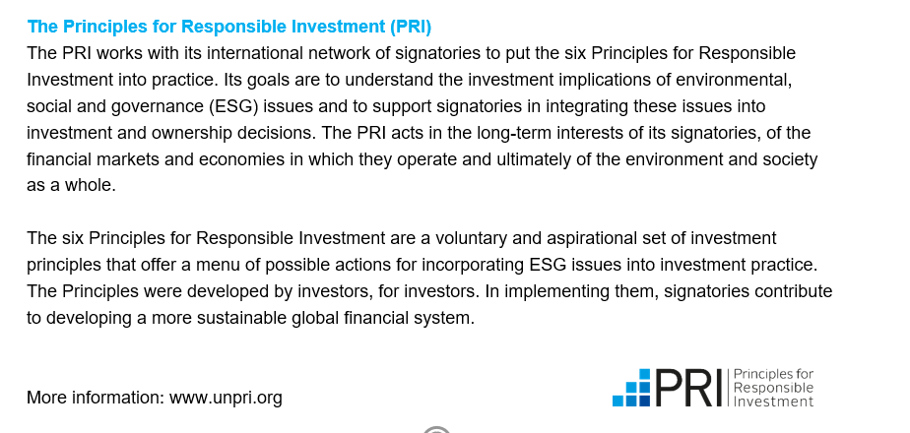

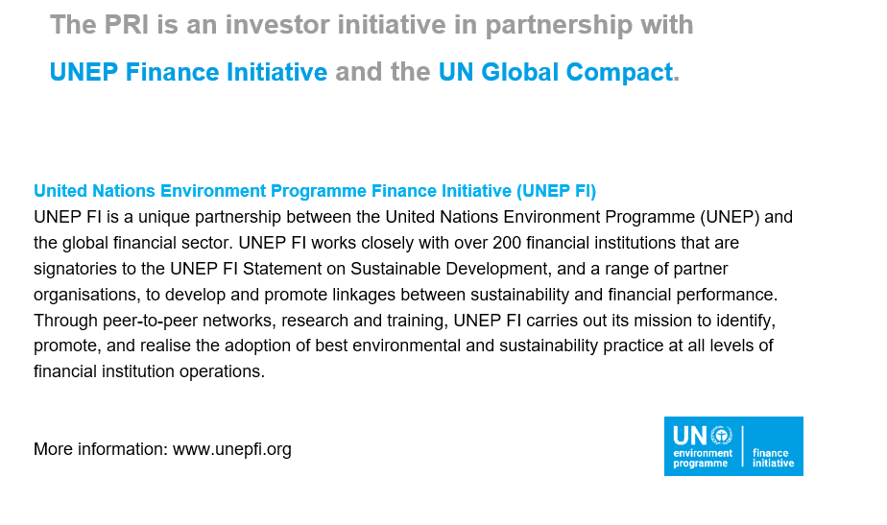
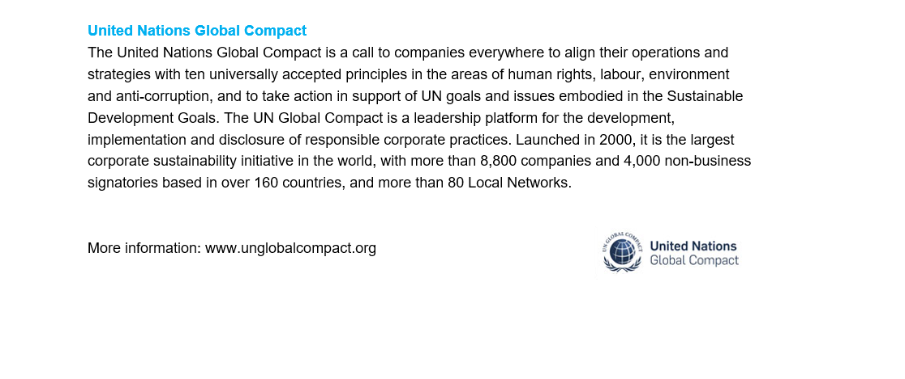

For further reference see Parts 1, 3, and 3 of the five-part SDG framework presented in PRI (2020) Investing with SDG outcomes.

