FAQ on mandatory climate reporting for PRI signatories

Edward Baker, Senior Specialist, Climate and energy transition

Senita Galijatovic, Head of Reporting & Accountability

In February last year, PRI announced that reporting against TCFD based indicators would become mandatory in 2020 for 2,085 signatories in 50 markets. The reporting framework is now live and will stay open until 31st of March.

Supporting signatories prepare and report on these climate risk indicators is a high priority. Following on from a webinar held earlier this month, this paper provides an overview on key and commonly asked questions. Should you have additional questions please contact [reporting@unpri.org](mailto:reporting@unpri.org).

**Q1. What are the TCFD recommendations?**

The recommendations from the the Financial Stability Board’s Taskforce on Climate-related Financial Disclosure (TCFD) provide a common international framework for companies and investors to translate information about climate change in financial metrics.

**What did the TCFD recommend?** Disclosing against eleven questions clustered under four categories: governance, strategy, risk management and metrics.

The recommendations seek to mainstream the management of climate-related risks and opportunities and provide a framework through which organisations can test the resilience of their strategy to climate impacts and policy goals

**Who are the recommendations for?** Both companies, banks, insurers and investors. The TCFD considers investors to be both users and the issuers of climate-relate disclosures.

**Where should the disclosures take place?** In companies’ and investors’ regular financial filings (e.g. annual report or periodic client reporting).

**The TCFD recommendations**

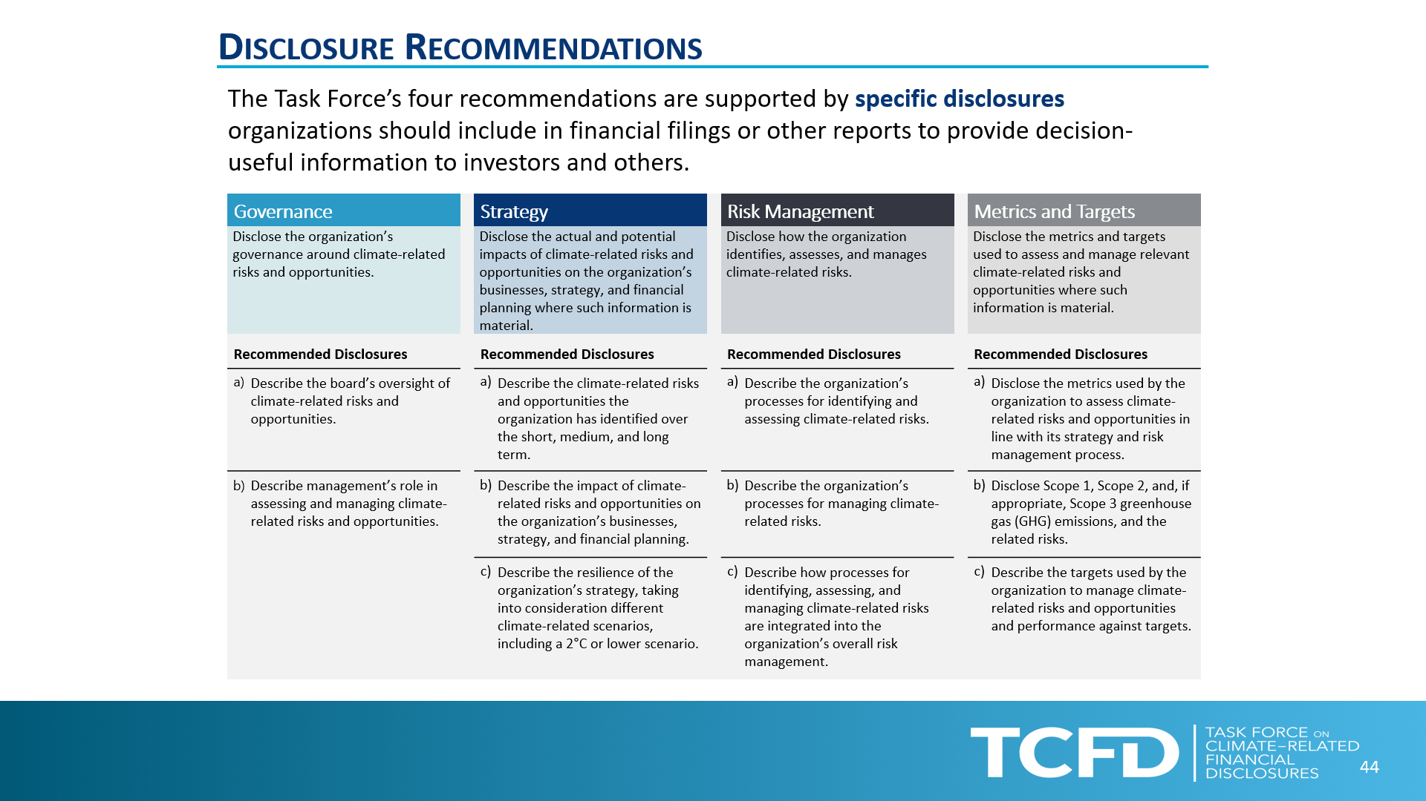

**Q2. What indicators are mandatory to report on?**

The specific indicators are SG 1 CC, SG 7 CC and SG 13 CC and available [here](https://d8g8t13e9vf2o.cloudfront.net/Uploads/o/k/u/03.cc2020_125127.pdf) (with guidance notes on each indicator question).

The three indicators consist of a total of 17 different sub-indicator questions. They relate to the identification of climate-related risks and opportunities, the board’s oversight, as well as the integration with investment strategy and climate scenario analysis.

**Q3. How do the TCFD recommendations and the PRI climate indicators differ?**

Whilst drawn from the TCFD recommendations, PRI’s climate indicators do differ in several important respects:

* What needs to be reported. The responses sought by the PRI climate indicators are more descriptive in nature, whereas the TCFD recommendations seek a balance of qualitative and quantitative reporting.
* Where the disclosures are made. A TCFD report should be published in the mainstream financial filings, which for listed companies could be subject to audit, whereas signatory reporting to PRI is self-reported data.
* The PRI **climate indicators are mandatory to report on, *but* voluntary to disclose.** Whereas TCFD is a disclosure framework, implementing it necessarily involves public reporting.

The indicators are designed to **complement, not replace, TCFD reporting** and are a means for signatories to try climate-related reporting and compare their responses with peers.

Q4. **What are the commercial benefits and drivers of TCFD and PRI climate reporting in markets where there is no regulatory pressure on climate change?**

This is likely to be a key starting question companies and investors, particularly in markets where climate change is politically charged. While the answer will vary, in short, investors could have capital at risk. Moreover, the drivers of which are multi-dimensional and in some cases, will be a growing risk-factor for investors, regardless of politics.

* **reputational risk:** the probability of profitability loss following a business’s activities or positions that the public or clients considers harmful
* **regulatory pressure and / or a formal regulatory requirement**: government action that could encourage or formally require climate-related disclosure. As set out in the [Inevitable Policy Response](https://www.unpri.org/esg-issues/environmental-issues/climate-change/inevitable-policy-response), the longer the delay in reducing emissions, the greater the policy jolt is likely to be.
* **litigation risk**: company directors and investors may face legal liability exposure in event that they fail to manage or report material financial risks. A [review](http://www.lse.ac.uk/GranthamInstitute/wp-content/uploads/2019/07/GRI_Global-trends-in-climate-change-litigation-2019-snapshot-2.pdf) of 1,328 climate ligation cases in 28 countries, found an increase trend of claims against companies and investment funds.
* **the changing economics of energy sector.** The energy transition is also market as well as policy driven. Intra-energy competition between renewables and conventional technologies like coal, gas & nuclear, is changing the economics of the sector. A similar trend is also apparent in the automotive sector. and will continue, to an extent, independently of policy. See [here](https://docfinder.bnpparibas-am.com/api/files/1094E5B9-2FAA-47A3-805D-EF65EAD09A7F), for an example of research on this area.
* **exposure of portfolios to physical damages from climate change**. In the near term, climate change is changing the odds on extreme weather, which could disrupt trade, damages real estate assets and infrastructure. As well as these events, investors also face risk from climate trend sea level risk, drought, spread of pathogens and the non-linear rate of climatic change that would be irreversible on human timescales. These risks, including the limits to adaptation, have been documented [here](https://www.ipcc.ch/report/ar5/syr/).

The benefits of the TCFD are therefore as a common and flexible framework that can help investors assess, monitor and manage climate-related risks and better position themselves for new market opportunities

**Q5. How can I get started?**

There is unlikely to be any one single way to answer this question, as it relates to how firms are organised and how they undertake investment practice. But image below provides an indicative four step approach that investors could take in investigating and implementing TCFD, which could also be of relevance for the PRI climate indicators

**Four step approach to implementing TCFD**



In addition, organisations may start with reviewing their existing approach to climate change and, from the financial filings, the extent of their investments are in energy intensive sectors. Free-to-use of the shelf climate scenario tools may assist with this analysis. Developing familiarity with the Taskforce’s recommendations and investigating the work of peers is also suggested at this stage. The chart below provides an overview of free-to-use tools that are available for assessing climate transition risk.. In distinguishing between them, investor could look at the functionality of outputs that these tools provide, such as:

* **Alignment test** on the degree to which the portfolio meets or overshoots climate goals
* **Company information** which could be used in corporate engagement
* **Financial analysis** of the value in portfolios that could be at risk

Other factors include the coverage of asset classes and whether the tool is primarily for portfolio screening or sector level analysis.

**Overview of free-to-use tools for assessing climate transition risks**

|  |  |  |  |  |
| --- | --- | --- | --- | --- |
| **Name** | **Asset classes** | **Alignment test** | **Company engagement** | **Financial analysis** |
| Portfolio screening tools | | | | |
| [PACTA](https://www.transitionmonitor.com/) | Equities, corporate bonds |  | Underdevelopment |  |
| [IPR](https://www.unpri.org/esg-issues/environmental-issues/climate-change/inevitable-policy-response) | Equities, corporate bonds |  |  |  |
| Sector / company engagement tools | | | | |
| [TPI](https://www.transitionpathwayinitiative.org/) | Equities |  |  |  |
| [Carbon Tracker](https://www.carbontracker.org/) | Oil and gas, coal equities |  |  |  |
| [Science based targets initiative](https://sciencebasedtargets.org/) | [integration planned with PACTA] |  |  |  |

As well as which tools to use, investors also need to consider **what scenarios are relevant** to their analysis. The TCFD recommends the use of a range of scenarios, including a 2⁰C or lower scenario. Yet, as well as a temperature outcome, it is also important to consider whether the path to will be smooth or abrupt. As the realities of climate change become increasingly apparent, it is inevitable, in PRI’s view, that governments will be forced to act more decisively than they have so far.

**Q5. What are the use cases of TCFD reporting and where are the examples of investors who have done this?**

As a disclosure framework, reporting is clearly an important part of TCFD. Yet, the disclosures are not the end goal, but rather the mechanism through which the Taskforce’s recommendations are implemented

Key applications of TCFD reporting are:

1. **Assessing the resilience of your investment strategy** – by testing portfolios under different climate constrained scenarios investors are able to consider a broader range of assumptions, uncertainties, and potential future states when assessing financial implications of climate change.

Investor examples of this include [Axa](https://www.axa.com/en/about-us/axa-and-climate-change), [Aviva](https://www.aviva.com/social-purpose/climate-related-financial-disclosure/), Allianz France and [GPIF](https://www.gpif.go.jp/en/investment/20190906_trucost.html), [CalSTRS](https://www.calstrs.com/sites/main/files/file-attachments/greeninitiativetaskforce2019.pdf?1577987516)

1. **Structuring corporate engagement** – the TCFD recommendations act as a useful framework for structuring engagement with portfolio companies. Investors can utilise TCFD disclosures to better understand how investee companies are exposed to climate-related risks.

Investor examples include the joint TCFD case study from [Storebrand and Equinor](https://www.cdsb.net/sites/default/files/equinor_and_storebrand_case_study_2018.pdf), [Pingan Group](http://www.pingan.com/app_upload/images/info/upload/1e5bab55-e0b5-43de-b664-155b2a02dde3.pdf)

1. **Embedding board oversight of climate-related risks and opportunities** – effective TCFD reporting requires cross-organisational collaboration and alignment, which means drawing many different teams to assess climate-related issues. TCFD reports can therefore help build capacity across the organisation of the understanding of climate-related risk and ultimately lead to more robust governance, strategy and risk management practices.

Investor examples include: [Cbus](https://www.cbussuper.com.au/about-us/sustainability), [CalSTRS](https://www.calstrs.com/sites/main/files/file-attachments/greeninitiativetaskforce2019.pdf?1577987516), [New York State Common](https://www.osc.state.ny.us/pension/climate-action-plan-2019.pdf)

In addition, reporting and aggregated analysis from the 2019 PRI climate indicators, including 221 investor climate reports (responses to the indicator questions) is available [here](https://www.unpri.org/climate-change/pri-climate-snapshot-2019/4788.article).

**Q6.** **Do I need to respond to the PRI climate indicators if my organisation already publishes a TCFD report?**

Yes. This is a requirement for all signatories that report to the PRI. You should be able to use your TCFD disclosures in your PRI reporting.

**Q7. Does PRI assess signatories’ responses to the climate indicators?**

No. The climate indicators are a non-assessed part of PRI’s reporting framework. Through the PRI climate snapshot report (hyperlink), we do provide anonymous interpretation of the responses, grouping signatories across four categories:

* **not reported**
* **responsive:** signatories opt to make the response to climate indicators private to the PRI or a public response but a description of scenario analysis is not provided.
* **responsible**: a public response to the climate indicator questions, including description of findings from climate scenario analysis.
* **strategic:** a public response, publicly supports TCFD, a board approved implementation plan, consider near and long term climate risks, published climate targets.

**Q8: Do investment consultant signatories need to respond to the climate indicators?**

No. Investor signatories only need to complete these TCFD based indicators. However, given the prominent role that investment consultants play in some markets, the relevance of TCFD type questions is currently being reviewed.

**Q9: What is meant by an ‘organisation wide strategy’ in indicator SG1.9 CC?**

Indicator question SG 1.9 CC asks signatories to “Indicate whether there is an organisation-wide strategy in place to identify and manage material climate-related risks and opportunities” and describe the plan in place.

Having board oversight and clear management processes in place is a key Taskforce recommendation. Hence, “organisation wide strategy” refers to implementing the TCFD recommendations needing to cover all portfolios and / or products and not standalone ESG schemes.

**Q10: What is the difference between SG 1.6 CC and SG 13.6 CC?**

Indicator SG 1.6 CC asks:

“[Describe] *whether your organisation has identified transition and physical climate-related risks and opportunities and whether this has been factored into the investment strategies and products, within the organisation’s investment time horizon*”.

And SG 13.6 CC:

“[Describe] *whether your organisation has evaluated the potential impact of climate-related risks, beyond the investment time horizon, on its investment strategy*.”

The difference of the two being the time frame of the analysis. A goal of TCFD is to bring a future risk (like climate change) into the present. The dose and delayed response characteristic of the earth’s climate system means that today’s emissions will take decades to reach the atmosphere and impact on society and the economy. As such the relying solely on historical data does not capture the financial risks posed by climate change and there is a need to assess over near to longer term time horizons.

**Q11. Where can I find more resources on TCFD and PRI climate indicators?**

PRI and external reports

* [The PRI Asset Owner guide to TCFD](https://www.unpri.org/climate-change/an-asset-owners-guide-to-the-tcfd-recommendations/3109.article): actions for asset owners, questions for consultants, investor examples and a chapter on climate scenarios.
* [The TCFD Knowledge Hub](https://www.tcfdhub.org/): an online portal for published resources on TCFD.
* [IIGCC’s Navigating climate scenario analysis](http://www.iigcc.org/files/publication-files/Navigating_climate_scenario_analysis_-_a_guide_for_institutional_investors.pdf): a guide for institutional investors.
* [UNEP-FI Changing Course](https://www.unepfi.org/publications/investment-publications/changing-course-a-comprehensive-investor-guide-to-scenario-based-methods-for-climate-risk-assessment-in-response-to-the-tcfd/): a guide to scenario-based methods for climate risk assessment.
* [Advancing TCFD guidance on physical climate risk and opportunities](https://www.physicalclimaterisk.com/EBRD-GCA_TCFD_physical_climate_final_report.pdf): report by EBRD and the Global Centre on Adaptation expands the TCFD’s guidance on physical climate risk

Climate scenario analysis

* [Directory of climate scenario tools:](https://www.unpri.org/climate-change/climate-scenario-analysis-/3606.article) Free-to-use and commercially available climate scenario tools can help make it easier for investors to implement a key recommendation of the TCFD – scenario planning.
* [Table of reference climate scenarios:](https://www.unpri.org/climate-change/climate-scenario-analysis-/3606.article) PRI Reporting Framework Indicator SG 13.8CC invites signatories to select which climate reference scenarios they use from a list.

PRI signatory reporting on the 2019 climate indicators

* [Climate snapshot report](https://www.unpri.org/climate-change/pri-climate-snapshot-2019/4788.article): analysis of investors’ response to the PRI 2019 climate risk indicators

Webinars

* [The TCFD recommendations and the 2020 PRI reporting cycle](https://www.brighttalk.com/webcast/17701/378894?utm_source=brighttalk-portal&utm_medium=web&utm_content=TCFD&utm_campaign=webcasts-search-results-feed): overview of TCFD and 2020 PRI climate reporting framework
* [Climate scenario analysis and PACTA](https://www.youtube.com/watch?v=6V48U-8zrP8): overview of climate scenarios, PACTA and California Insurance Commissioner.
* [TCFD: leaders and challenges](https://www.brighttalk.com/webcast/17701/368031?utm_source=brighttalk-portal&utm_medium=web&utm_content=TCFD&utm_campaign=webcasts-search-results-feed): joint webinar with the IFoA, Aviva and Carbon Delta